E- COMMERCE APPLICATION ON DEVELOPMENT PART-1

A PROJECT REPORT

Submitted by:

K. NIVETHITHA

S. SOWNDHARYA

M. SATHYA

S. PAVITHRA

S. SOWNDHARYA

In partial fulfillment for the award of the degree

BACHELOR OF ENGINEERING,

In

COMPUTER SCIENCE AND ENGINEERING

SASURIE COLLEGE OF ENGINEERING

Vijayamangalam, Tiruppur.

Cloud Computing of E-commerce

Tamara Almarabeh1 & Yousef Kh. Majdalawi1

1 Department of Computer Information Systems, The University of Jordan, Jordan

Correspondence: Tamara Almarabeh, Department of Computer Information Systems, The University of Jordan, Jordan. E-mail: [t.almaraabeh@ju.edu.jo](mailto:t.almaraabeh@ju.edu.jo)

Received: October 28, 2018 Accepted: November 8, 2018 Online Published: December 5, 2018 doi:10.5539/mas.v13n1p27 URL: https://doi.org/10.5539/mas.v13n1p27

# Abstract

Cloud computing affects on different sectors, including: E-learning, health care, and E-commerce. It offers online services in high efficiency and minimal cost which provide a high economic value. It is undoubtedly the next revolution in the Internet world as well as the business world.

Currently, more E-commerce enterprises move to Cloud Computing to achieve high practical value. This paper introduces an overview for Cloud computing in E-commerce through discussing various definitions for both concepts, highlighting the benefits and challenges for applying Cloud Computing in E-commerce, and discussing a suggested cloud computing E-commerce framework.

**Keywords:** cloud computing, e-commerce, ICT, Internet, SMEs

# Introduction

There is no doubt that we are living in an era where things are getting old while they are still in the top of their modernity, the pace of technological development is accelerating, and hardly a day goes by without a witness appeared on the essential changes in all sectors, including the business sector.

In the past, to sell products you have to rent physically an office space which added different expenses, then E- commerce appeared and gave the flexibility for enterprises to sell products online without any need to rent a shop like before. These days, many more E-commerce enterprises especially SMEs (Small and Medium sized Enterprises) take advantage of the benefits of cloud computing (Mann et.al., 2008), where the growing of this innovation led them to compete with the large enterprises in providing products and services as they have a large infrastructure despite their limited infrastructure (Abdulkader and Abualkishik, 2013).

The benefits of investment in cloud computing technology in businesses have been widely recognized (Armbrust et al., 2010) such as flexibility, reliability, enhancing the availability, and reducing the cost of E-businesses. (Tuncay, 2010).

# What is E-commerce?

E-commerce came into being since late 1970s. Many advantages of online shops encourage consumers to adopt, like lower costs, better prices than traditional retailers, and ability of consumers to compare prices from different retailers (Chaparro-Peláez et al., 2016, Chang et al., 2010).

The Electronic Commerce Association introduced a general definition of E-commerce: “electronic commerce covers any form of business or administrative transaction or information exchange that is executed using any ICT (Information and Communications Technology)".

Raymond (2001) defined E-commerce as “The functions of information are exchange and commercial transaction support that operate on telecommunications networks linking business partners (typically customers and suppliers)”.

Turban et al. (2002) defined it as “An emerging concept that describes the process of buying, selling, or exchanging services and information via computer networks”.

In general E-commerce can be categorized as:

1. Consumer to Consumer E-commerce (C2C E-commerce): The E-transactions between consumers themselves
2. Business to Consumer E-commerce (B2C E-commerce): Enterpises can sell to the consumers directly.
3. Business to Business E-commerce (B2B E-commerce): The E-transactions between Enterprises.
4. Consumer to Business E-commerce (C2B E-commerce): Consumers can sell products to the Enterprises.

Actually, there are many different types of E-commerce applications, which grouped in Figure1 according to categories (Arie et al.,1995, Block et al.,1996, Soh et al., 1997, Zwass, 1998, Turban et al., 2000, Ainin,2000, Fatimah et al., 2000, Fahri and Omar,2001, Oakes, 2002, Johnson, 2003, Ainin, and Jaffar, 2003, Smith and Chaffey, 2005, Lawal, 2010).

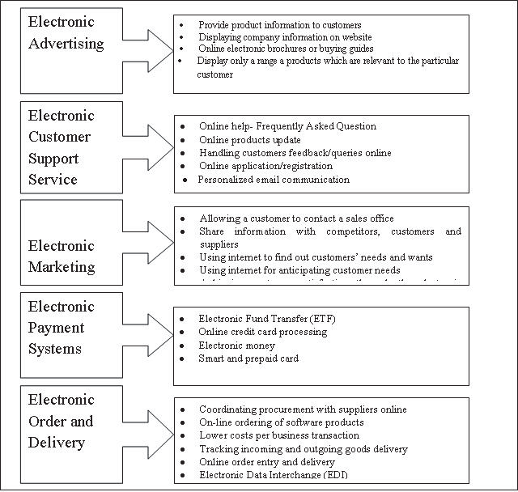

Figure 1. Applications of E-commerce

# What is Cloud Computing?

Many governments and businesses considered it as a revolutionary term. The term of cloud computing doesn’t have a unified definition at present. IEEE Computer Society defined it as (Kho, 2009): "A paradigm in which information is constantly stored in servers on the Internet and cached temporarily on clients that include desktops, entertainment centers, computers, notebooks, handhelds, etc”. It is an IT tool used to deliver computing as a service not a product.

Many scientists of NIST (National Institute of Standards and Technology) defined it as follows: "Cloud computing is a model for enabling convenient to access to networks and applications quickly, common set of configurable computing resources (e.g., networks, servers, storage and applications) that can work with little or interfere with the service provider to provide or be released immediately."

Other researchers like (Paul et.al, 2010) defined it as “A style of computing where massively scalable information technology related capabilities are provided as a service across the internet to multiple external customers”.

As shown in Figure 2(Arron, 2017), the cloud computing has three widely referenced service models. SaaS (Software as Service): It means that the end user will deal with the site remotely over the Internet. CRM (Customer Relationship Management), and the data center which displayed by Amazon Web Services are examples for this model. PaaS (Platform as a Service): The best example of PaaS is the Google App Store. It is primarily aimed at the developers’ activities who want to deploy their applications directly in the cloud server, and they haven't an interest in the connection to the infrastructure of the servers. And IaaS (Infrastructure as a Service): It

gives developers the permission to take the highest level of direct interaction with the infrastructure of servers. It also allows them to deploy their own applications in remote environment and to control them remotely. So far, the SaaS model is the dominant model in the current industry.

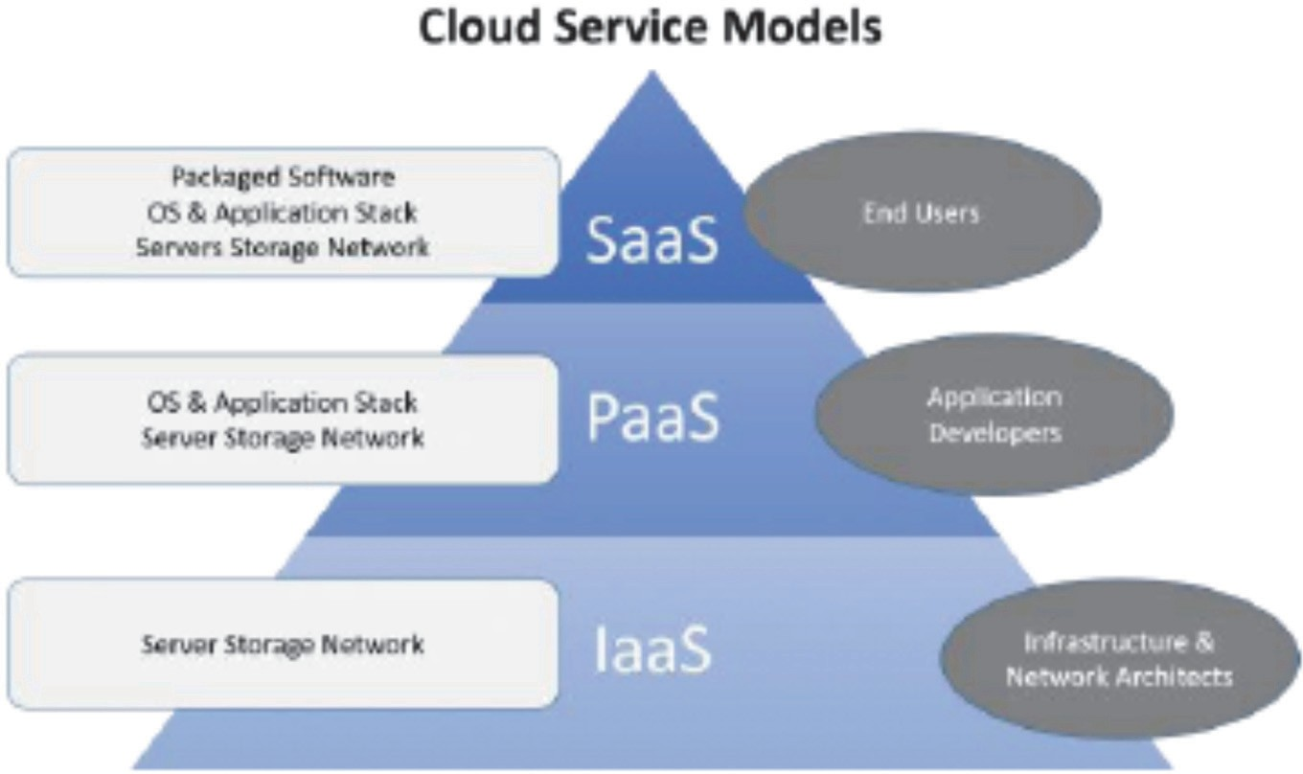

Figure 2. Models of Cloud Computing

# Why is Cloud Computing in E-commerce?

Cloud Computing and E-commerce are now two famous terms in our daily lives. The main reason of this reputation returns to cost beneficial where cloud computing service saves enterprise’s the cost of IT infrastructure, on the other hand E-commerce provides traders to do business without expenses like renting or buying a business shop.

The adoption of cloud computing and E-commerce in developing countries have been widely discussed by several researches, which showed that these innovations leveraged the developing countries in transforming into digital economy leading to global market penetration and national economic growth (Busalim and Hussin 2015; Khan et al. 2017; Nawaz et al. 2016; Rukhsara et al. 2016; Yu and Ni 2013, Dai et al. 2014; Guo and Gao 2015; Liu and He 2017; Rao et al. 2013, Neumann et.al. 2010, Talib and Alomary 2016, Goel and Goel 2017).

No one can deny that cloud gives positive opportunities and benefits for E-commerce, but smart organization should have a trade-off between costs before using it. The cloud computing allows organizations to perform business without having to develop and retain IT infrastructure. E-commerce provides the flexibility for business to sell products online without having to physically rent an office, but still there are expenses related to hardware and software resources. These days, many more E-commerce enterprises obtain advantages of the profit of cloud computing (Nevin, 2015, Jignesh 2014, Abdulkader and Abualkishik, 2013) as shown in Table 1.

Table 1. Advantages of Cloud Computing in E-commerce

# Advantage Description

Cost saving Reducing IT resources, installation, and implementation.

Scalability The business requirements are changing constantly. Cloud computing enable rapid adaptations of IT to these changes.

Efficiency IT organizations can concentrate on its businesses and get benefits through development and innovative research

Availability and Mobility Through smartphones, customers can access services and products anytime and anywhere.

Easy management Maintenance of hardware, software, and even infrastructure is simplified.

According to Gartner Group (Gartner, 2016), as shown in Table 3. The worldwide public cloud services market is projected to grow 21.4% in 2018 to total $186.4 billion, up from $153.5 billion in 2017. The fastest-growing

segment of the market is cloud system infrastructure services (IaaS), which is forecast to grow 35.9% in 2018 to reach $40.8 billion (see Table 2). SaaS remains the largest segment of the cloud market, with revenue expected to grow 22.2% to reach $73.6 billion in 2018.

Gartner expects the growth rates of public cloud to stabilize from 2018 onward even though the revenue of it is growing more strongly than forecast, reflecting the status and maturity that public cloud services.

Table 2. Worldwide Public Cloud Service Revenue Forecast (Billions of U.S. Dollars)

|  |  |  |  |  |
| --- | --- | --- | --- | --- |
| **2017** | **2018** | **2019** | **2020** | **2021** |
| Cloud Business Process Services |  |  |  |  |
| (BPaaS) 42.6 | 46.4 | 50.1 | 54.1 | 58.4 |
| Cloud Application Infrastructure |  |  |  |  |
| Services (PaaS) 11.9 | 15.0 | 18.6 | 22.7 | 27.3 |
| Cloud Application Services (SaaS) 60.2 | 73.6 | 87.2 | 101.9 | 117.1 |
| Cloud Management and Security |  |  |  |  |
| Services 8.7 | 10.5 | 12.3 | 14.1 | 16.1 |
| Cloud System Infrastructure Services |  |  |  |  |
| (IaaS) 30.0 | 40.8 | 52.9 | 67.4 | 83.5 |
| **Total Market 153.5** | **186.4** | **221.1** | **260.2** | **302.5** |

The most challenges to be faced in applying cloud computing in E-commerce (Abdulkader and Abualkishik, 2013, Nevin, 2015, Al-Jaberi et.al 2015, Babar and Chauhan, 2011, Buyya et.al, 2008) are presented in Table 4.

Table 3. Main challenges of applying cloud computing in E-commerce

# Challenge Description

Security It is the main challenge, where data can be accessed, modified, or even destroyed during processing or transmission. Until now, it is hard to protect programs and data and there are no effective solutions.

Data Privacy It is an important challenge, until now no technical solutions to protect the clients' information.

Data Storage The clients of cloud services worry regarding their inability to control of stored data place.

Trust As a definition trust is “the degree by which a target object such as software, a device, a server, or any data they deliver is considered secure.” Until now, it is difficult for consumers to distinguish between good and bad E-commerce sites. This situation does not encourage enterprises and clients to move to the cloud.

Connectivity In the cloud, to access shared information or resources the user must be connected to Internet.

Service standards issues No available information for enterprises regarding mode of operations, technology used, and staff situation which let the clients are worrying to use cloud computing without knowing these details.

# How is Cloud computing work in E-commerce?

The employment of cloud computing into E-commerce will bring a tremendous business change to enterprises. Figure 3 summarizes various influences of cloud computing on SME’s E-commerce (Yu J and Ni J, 2013). The impacts are obvious and multifaceted in terms of deployed technology, service, and business model.

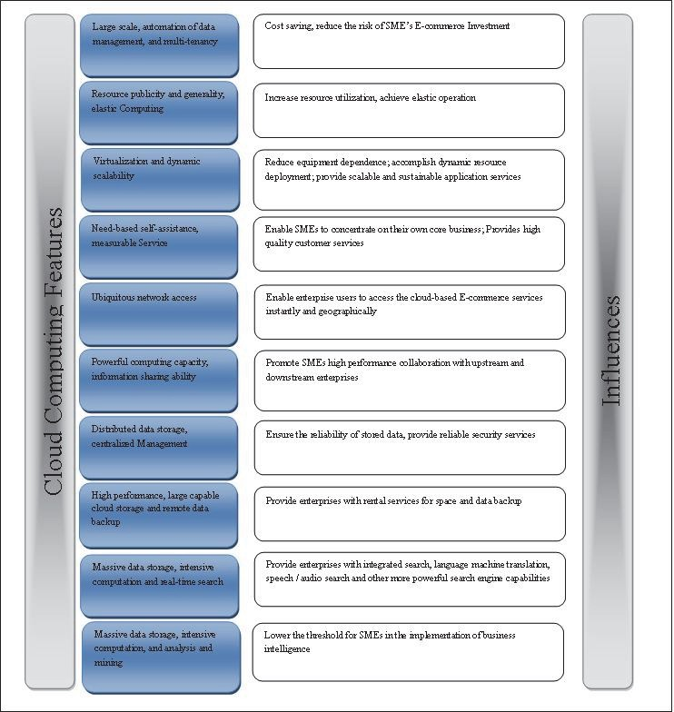

Figure 3. Cloud Computing Influences on SMEs E-Commerce

The E-commerce industry chain is composed of the hardware supplier, software developer, Internet service provider, system integrating provider, and service supplier where they exist as the backend of the enterprise and offer the technical support as shown in Figure 4 (Wang, 2013). While when the cloud computing is migrated into E-commerce, the structure of E-commerce industry chain will be changed as shown in Figure 5 (Wang, 2013).

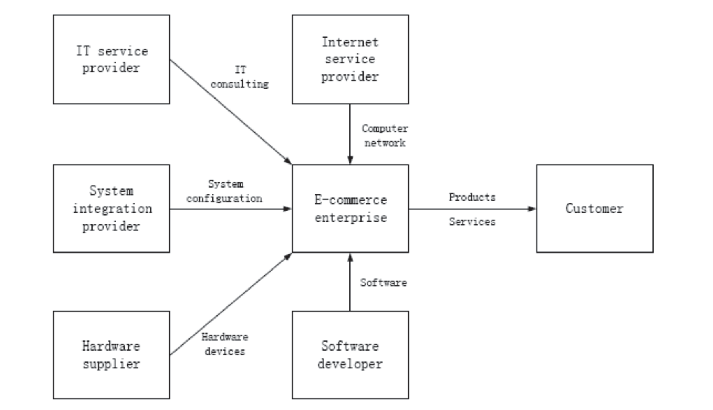

Figure 4. Traditional E-commerce industry chain

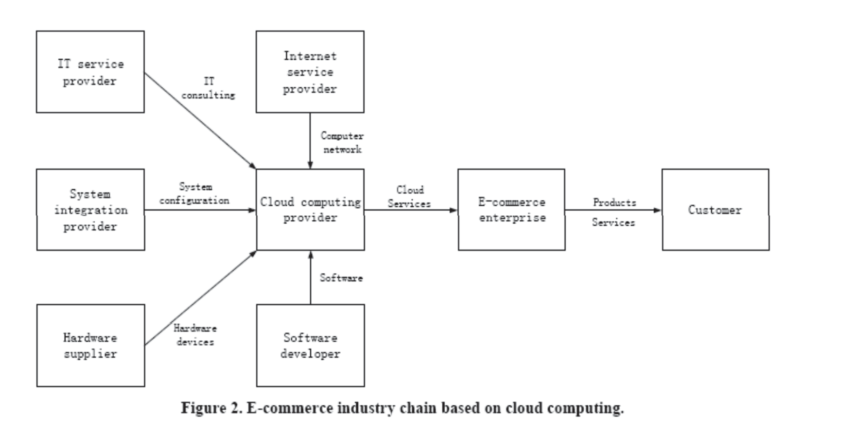

Figure 5. E-commerce industry chain based on cloud computing

The researcher Akinyede in his research (Akinyede, 2018) proposed a new framework for using cloud computing in E-commerce applications to solve problems related with lack of resources and the environmental cost for developing and implementing an E-commerce system. It consists of five layers as you can see in Figure 6. This framework reduces the implementation time and cost of hardware and software. But it doesn’t address other challenges like the cloud services standards, regulatory issues, and security of the applications and platforms.

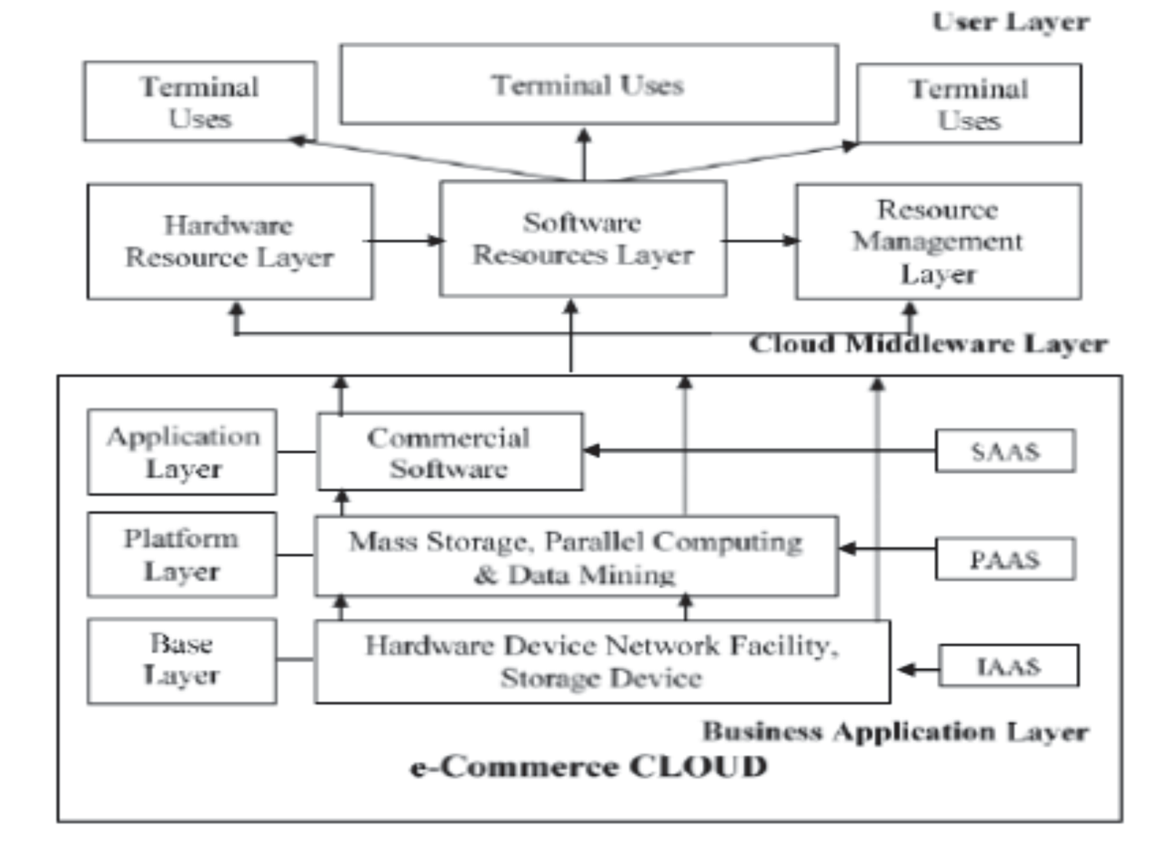

Figure 6. Proposed Cloud Computing based E-commerce Framework

# 5. Conclusion

The cloud computing is expanding and spreading as a business solution since it has shown effective and positive results which put it in the top-flight of ICT technologies i.e. Flexibility in the space and enormous support for infrastructure and software This innovation has many potentials that increase revenue, expand business and create new jobs that extend to large sectors not only in the business sector. It plays a vital role in the smart economy. Without doubt it will be the fifth utility after water, gas, electricity, and telephony which are always-on and paid by usage of consumer.

# References

Abdulkader, S. J., & Abualkishik, A. M. (2013). Cloud Computing and E-commerce in Small and Medium Enterprises (SME’s): The Benefits, Challenges. *International Journal of Science and Research (IJSR), 2*(12), 285-288.

Ainin, S. (2000). Status of E-commerce Application in Malaysia. *Information Technology for Development Journal, 9*(3/4), 153-161. https://doi.org/10.1080/02681102.2000.9525329

Ainin, S., & Jaffar, N. (2003). E-commerce Stimuli and Practices in Malaysia. PACIS 2003 Proceedings.

Association for Information Systems AIS Electronic Library (AISeL).

Akinyede, R. O. (2018). Proposed E-Commerce Framework Using Cloud Computing Technology”. *International Journal of Computer Science Trends and Technology (IJCST), 6*(3), 2018.

Al-Jaberi, M., Mohamed, N., & Al-Jaroodi, J. (2015). e-Commerce Cloud: Opportunities and Challenges, in proc. 5th Int’l Conference on Industrial Engineering and Operations Management (IEOM 2015), IEEE, Dubai, UAE, Mar. 3-5, 2015.

Arie, S., Dadong W., & Caroline, B. (1995). Financial EDI over the Internet: A Case Study. Working Paper CITM- WP-1006. Fisher Center for Information Technology & Management, University of California in Berkeley.

Armbrust, M., Fox, A., Griffith, R., Joseph, A. D., Katz, R., Konwinski, A., & Zaharia, M. (2010). A view of cloud computing. *Communications of the ACM, 53*(4), 50–58. https://doi.org/10.1145/1721654.1721672

Arron Fu, (2017). *Different Types of Cloud Computing Structures.* Copyright © 2018 UniPrint.net. Retrieved from http[s://www](http://www.uniprint.net/en/7-types-cloudcomputing-structures/).u[nip](http://www.uniprint.net/en/7-types-cloudcomputing-structures/)r[int.n](http://www.uniprint.net/en/7-types-cloudcomputing-structures/)e[t/en/7-types-cloudcomputing-structures/](http://www.uniprint.net/en/7-types-cloudcomputing-structures/)

Aydin N. (2015), Cloud Computing for E-Commerce, IOSR Journal of Mobile Computing and Application (IOSR- JMCA) e-ISSN: 2394-0050, P-ISSN: 2394-0042. 2(1). (Mar. - Apr. 2015), PP 27-31.

https://doi.org/10.9790/0050-0212731

Babar, M. A., & Chauhan, M. A. (2011). A tale of migration to cloud computing for sharing experiences and observations.2011.ACM.

Block, M., Yves, P., & Arie, S. (1996). On the Road of Electronic Commerce- a Business Value Framework, Gaining Competitive Advantage and Some Research Issues. Working Paper: Fisher Center for Information Technology and Management, University of California, Berkeley.

Busalim, A. H., & Hussin, A. R. C. (2015). An Integrated Framework for E-commerce Cloud Service Level Agreement, Pacific Asia Conference on Information Systems, PACIS 2015 - Proceedings.

Buyya, R., Yeo C. S., & Venugopal, S. (2008). Market – oriented cloud computing: Vision, hype, and reality for delivering it services as computing utilities. 2008. IEEE

Chang, M, L., Lai, M., & Wu, W, Y. (2010). The influences of shopping motivation on adolescent online-shopping perceptions. *African Journal of Business Management, 4*(13), 2728– 2742.

Chaparro-Peláez, J., Agudo-Peregrin, A.F., Pascual-Miguel, F.J. (2016). Conjoint analysis of drivers and inhibitors of E-commerce adoption. Journal of Business Research, 69(4), 1277-1282.

Dai, W., Zhang, X., & Hu, P. (2014). A Study on Security Technique of Cloud Data Processing in Electronic Commerce. *International Journal of Security and its Applications, 8*(2), 283-290.

Fahri, K., & Omar, K. (2001). Electronic Commerce Use in Small and Medium-Sized Enterprises in Towards the E-Society E-commerce, E-business, E-Government. In Schmid, B., Stanoevska, K., & Tschammer, V. (Eds), Kluwer Publishing, Zurich, 329-340.

Fatimah, M. A, Kusairi, M. N., & Mohd, F. A. (2000). E-commerce Adoption in Malaysia: Problems and Barriers from the Firms Perspective. International Conference on Electronic Commerce Proceedings, 21-23 November, Kuala Lumpur.

Gartner. (2018). Gartner Forecasts Worldwide Public Cloud Revenue to Grow 21.4 Percent in 2018. Retrieved from http[s://www](http://www.gartner.com/newsroom/id/3871416).g[artn](http://www.gartner.com/newsroom/id/3871416)er[.com/newsroom/id/3871416](http://www.gartner.com/newsroom/id/3871416)

Goel, K., & Goel, M. (2017). Cloud Computing Based E-commerce Model, 2016 IEEE International Conference on Recent Trends in Electronics, Information and Communication Technology, RTEICT 2016 - Proceedings, pp. 27-30. https://doi.org/10.1109/RTEICT.2016.7807775

Guo, H., & Gao, S. (2015). Exploring Driving Factors for Consumers' Acceptance of E-commerce in Chinese Rural Areas, Proceedings of the International Conference on Electronic Business (ICEB), pp. 258-261.

Jignesh, P. S. (2014). Role and Challenges in Cloud Computing and E-commerce in SME’s. *International Multidisciplinary Research Journal,* 1(3), 1-4.

Johnson, C. (2003). U. S E-commerce: the year in review, Cambridge, MA: Forrester Research.

Khan, M., Xu, X., Dou, W., & Yu, S. (2017). Osaas: Online Shopping as a Service to Escalate E-commerce in Developing Countries, Proceedings - 18th IEEE International Conference on High Performance Computing and Communications, 14th IEEE International Conference on Smart City and 2nd IEEE International Conference on Data Science and Systems, HPCC/SmartCity/DSS 2016, pp. 1402-1409. <http://doi.ieeecomputersociety.org/10.1109/HPCC-SmartCity-DSS.2016.0200>

Kho, N. D. (2009) Content in the Cloud. *E Content, 32,* 26-30.

Lawal, A. S. (2010). Electronic commerce in Nigeria banking industry (a case study of guaranty trust bank Nigeria plc.) department of business administration, faculty of business and social science, university of Ilorin, Ilorin.

Liu, P., & He, W. (2017). Research on the E-commerce Operation Performance of Smes Based on Cloud Computing Service Platform. *Revista de la Facultad de Ingenieria*, *32*(3), 500-509.

Mann, R., Lara N., Kazarian, M., Johnson, J., & Kemble, J. (2008). B2B E-commerce: Why it business should incorporate E-commerce. 2008. Retrieved from https://docplayer.net/12255715-B2b-e-commerce-why-it- business-should-incorporate-e-commerce-written-by-rachel-mann-nikkilynn-lara-michael-kazarian-jude- johnson-jacob-kemble.html

Nawaz, S., Malik, A. W., Shafi, A., & Khan, S. U. (2015). Cloud and E-Commerce Adoption, 2015 12th International Conference on High-Capacity Optical Networks and Enabling/Emerging Technologies,

HONET-ICT 2015.

Neumann, R., Dumke, R., & Schmietendorf, A. (2010). Organic Product Catalogs: Towards an Architecture for Cloud-Based Micro Enterprise E-commerce, 2010 IEEE 3rd International Conference on Cloud Computing, pp. 530-531. https://doi.org/10.1109/CLOUD.2010.54

Oakes, C. (2002). Successful E-commerce means going back to the basics. *International Herald Tribune, 24*, 12. Paul, P., Felician, A., & Marius, V. (2010). Measuring the efficiency of cloud computing for elearning systems.

*WSEAS transactions on computers, 9*(1), 2010.

Rao, T. K. R. K., Khan, S. A., Begum, Z., & Divakar, C. (2013). Mining the E-commerce Cloud: A Survey on Emerging Relationship between Web Mining, E-commerce and Cloud Computing, 2013 IEEE International Conference on Computational Intelligence and Computing Research, IEEE ICCIC 2013. https://doi.org/10.1109/ICCIC.2013.6724234

Raymond, L. (2001) Determinants of Web Site Implementation in Small Business Internet Research. *Electronic Network Applications and Policy, 11*(5), 411 – 422.

Rukhsara, L., Aklam, F., Nawer, T., Chauhan, N. S., & Islam, M. N. (2016). A Conceptual Cloud-Based Model for Developing E-commerce Applications in Context of Bangladesh, 2016 5th International Conference on Informatics, Electronics and Vision, ICIEV 2016, pp. 117-121. https://doi.org/10.1109/ICIEV.2016.7759979

Smith, P. R., & Chaffey, D. (2005) E-Marketing Excellence: At the Heart of E-Business. Butterworth Heinemann, Oxford, UK.

Soh, C., Quee, M., Fong, G., Chew, D., & Reid, E. (1997). The use of the Internet for business: the experience of early adopters in Singapore, Internet Research. *Electronic Network Application and Policy, 7*(3), 217-228.

Talib, A. M., & Alomary, F. O. (2016). Cloud Computing Based E-commerce as a Service Model: Impacts and Recommendations, ACM International Conference Proceeding Series. https://doi.org/10.1145/2896387.2896412

The National Institute of Standards and Technology. Retrieved from <http://csrc.nist.gov/publications/nistpubs/800-> 145/SP800-145.pdf

Tuncay, E. (2010). Effective use of cloud computing in educational institutions. *Procedia: Social and Behavioral Sciences, 2*(2), 938–942. https://doi.org/10.1016/j.sbspro.2010.03.130

Turban, E., King, D., Lee, J., Warkentin, M., & Chung, H. M. (2002). Electronic Commerce Prentice Hall. Turban, E., McLean E., & Wetherbe J. (2000). Information Technology for Management, NY: John Wiley & Sons.

Inc.

Wang, D. (2013). Influences of Cloud Computing on E-Commerce Businesses and Industry. *Journal of Software Engineering and Applications, 6*, 313-318 <http://dx.doi.org/10.4236/jsea.2013.66039>

Yu, J., & Ni, J. (2013). Development Strategies for SME E-commerce Based on Cloud Computing, Proceedings - 2013 7th International Conference on Internet Computing for Engineering and Science, ICICSE 2013, pp. 1-8. https://doi.org/10.1109/ICICSE.2013.9

Zwass, V. (1998). Structure and Macro- Level Impacts of Electronic Commerce, CA: Saga Publication.

# Copyrights

Copyright for this article is retained by the author(s), with first publication rights granted to the journal.

This is an open-access article distributed under the terms and conditions of the Creative Commons Attribution license [(http://creativecommo](http://creativecommons.org/licenses/by/4.0/))n[s.org/licenses/by/4.0/).](http://creativecommons.org/licenses/by/4.0/))

[View publication stats](https://www.researchgate.net/publication/329417336)